Weeks 9-10 - Year 2 O.L.D
Students should also be encouraged to read each day and play games with your family!
Work can be recorded in your maths grid book or the writing book in your folder.

Subject | Topics | Suggested activities
English | - Language features – verbs, adjectives | - Sentence writing:  Put a circle around the words that describe (adjectives) the characters.  Put a circle around the action words (verbs).
 | Reading-  - Compare texts  - Strategy- Retell | - Read your two picture books and compare which one you like.  - See the pictures below of the class example of a character comparison using “Olga the Brolga” and “Giraffes can’t dance”.  - Write about your favourite character.  - Write a sentence giving reasons why.  - Retell the story in your own words or draw comic strip of the main events.
 | Spelling focus:  - ‘ou’ eg: around  - ‘oo’ eg look | - Make a list words of match this pattern.  - Make a bingo game with words.  - Make a game of memory.  - Write words in a sentence  See the pictures of the class posters below.  Soundwaves login  Student code - moth244
 | Handwriting | - Complete 15 mins of the next page of your writing books.
Numeracy | Number  - Counting patterns  - Addition and subtraction  - Word problems  iMaths  Student login  them280 | - Counting patterns 2’s 3’s 10’s  - Start from a number in the hundreds and count forward or backwards eg: 110 - 300  - Create a number problem using addition or subtraction based on something around the house.  - For example: Mum has 3 lines of washing each with 4 shirts on each line. How many shirts does mum hang out?  Work for 15mins on Maths Mentals book each school day.  Please note:  Every student will be on a different week of their book when they took it home. As a class we did not follow Maths Mentals each week of term, however many students are keen to complete more weeks. Students over the holidays must not go past week 10. This book will need to be returned to school after the holidays.
 | Location:  - Review maps and location | - Draw a map of your bedroom in your grid book.  - Label your bed, door, window, cupboards and toys.  Extra challenge use a grid reference using numbers and letters.
 | Shapes:  - Explore 2D shapes | - Draw and label some 2D shapes in your grid book.  - Make a pattern with two or mare shapes.
Religion | Compassion for others | Jesus taught us to love one another.  What story does Jesus tell that includes a Samaritan, Levite and Priest?  Share the story with your family.
Science | Growing and changing  Review how our beans are growing. | Editable garden  See the picture below on how our Dwarf beans are growing.  Write a sentence describing how the bean has grown.

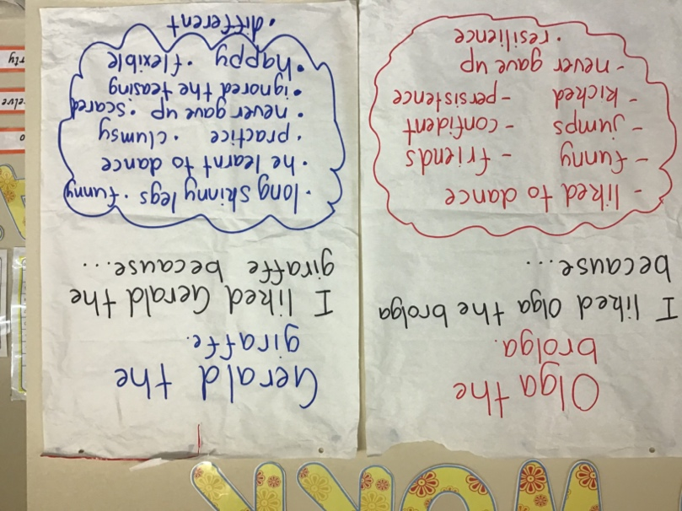  character comparison | 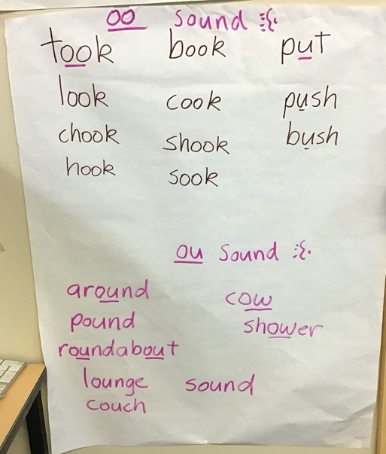  class posters spelling
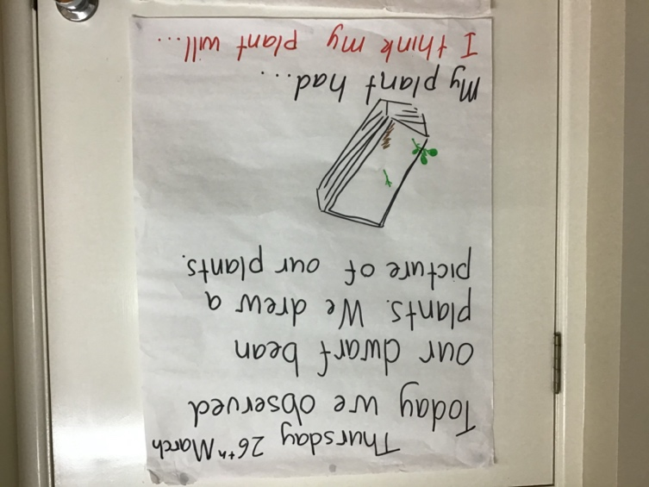  Editable garden | 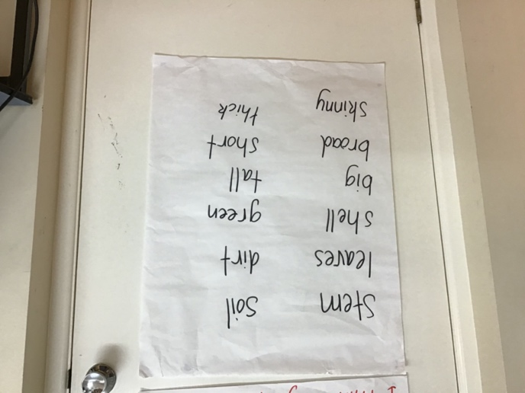Words to help with our sentence writing.
